NATIONAL REAL-TIME PAYMENTS SYSTEM
Solution Architecture: Eight Critical Design Questions

Parameter | Requirement
Registered Users | 150 Million
Daily Active Users | 40 Million
Peak Concurrent | 5 Million
Baseline Throughput | 50,000+ TPS
Peak Throughput (festivals/salary days) | 500,000 TPS
End-to-End Latency | < 2 Seconds
Availability Target | 99.999% (Five Nines)
Compliance | PCI DSS + ISO 27001
Fraud Detection | Real-Time, Non-Blocking
Data Residency | In-country only
Expansion | Cross-border ready

Global Reference Systems
Before designing any new system, it is good engineering practice to study how similar problems have been solved around the world. The systems listed below were studied as references for this assignment. They are not being copied directly rather, specific design decisions from each system have been adapted to the requirements of this National Real-Time Payments System (NRTPS).

Why Study Global References?
Every system listed below solved the core problem of moving money instantly between millions of users at national scale. By understanding their architectural choices and their failures we can design a better system without repeating known mistakes.

Reference Systems Summary Table
Payment System | Country / Region | Peak TPS (Transactions Per Second) | Key Strength | Relevance to This Assignment
UPI (Unified Payments Interface) | India | ~5,000 – 10,000 TPS | Open API ecosystem, VPA (Virtual Payment Address) model | Closest architectural match: 150 M+ users, P2P + P2M, QR codes, bank integrations
PIX | Brazil | ~12,000 TPS (peak) | 24x7 mandatory for all licensed institutions, instant settlement | Regulatory mandate model, low latency, dispute handling
FPS (Faster Payments Service) | United Kingdom | ~1,000 – 3,000 TPS | Pioneer of real-time retail payments (2008), ISO 20022 messaging | Messaging standards, settlement architecture
RTP (Real-Time Payments) by The Clearing House | United States of America | ~1,000 TPS | Private-sector bank consortium, 24x7 credit push | Consortium governance, bank integration model
PromptPay | Thailand | ~500 – 1,000 TPS | Proxy-based addressing (ID, phone number, e-wallet) | Alternative identifier models beyond bank account numbers

Detailed Notes on Key References

UPI Unified Payments Interface (India) Primary Reference
UPI, launched in 2016 by the National Payments Corporation of India (NPCI), is the single most relevant reference for this assignment. Here is why:
- Scale: Over 300 million active users and 10 billion+ monthly transactions as of 2024 comparable to the 150 million registered users and 40 million daily active users in our assignment.
- Architecture: UPI uses a two-layer architecture a central switch (NPCI) sits between banks and handles routing, while participant banks host their own Payment Service Provider (PSP) applications. This is exactly the architecture recommended in this report.
- QR Payments: UPI introduced the BharatQR standard for merchant payments, which is a direct analogue to the QR-based P2M (Peer-to-Merchant) payments required in our assignment.
- Virtual Payment Address: Instead of sharing bank account numbers, users create a Virtual Payment Address (VPA) like name@bankname — this abstraction layer is a key security and usability feature we have adopted.
- Limitations and Lessons: UPI has struggled with fraud as scale grew, and the initial architecture did not anticipate the 10x traffic spikes during festivals like Diwali. Our design incorporates auto-scaling and pre-warming specifically to address this lesson.

PIX (Brazil) — Settlement and Regulatory Reference
PIX was launched in November 2020 by the Banco Central do Brasil (BCB Central Bank of Brazil). Within six months of launch, it had 100 million users the fastest adoption of any payment system in history. Key lessons:
- Mandatory Participation: BCB mandated all financial institutions above a certain size to participate. This eliminated the 'chicken and egg' problem of getting banks on board. Our design assumes a similar regulatory mandate.
- 24x7 Instant Settlement: Unlike older systems where settlement happened in batches (e.g., end of day), PIX settles every transaction instantly at any time of day or night. Our system follows this model.
- Alias System: PIX uses CPF (individual tax number), CNPJ (business tax number), phone number, or email as payment aliases, avoiding the need to share bank account details. We recommend a similar alias registry.

FPS Faster Payments Service (United Kingdom) Messaging Standards Reference
FPS, launched in 2008 by the UK Payments Council, was the world's first successful real-time retail payment system. Key lessons:
- ISO 20022 Messaging: FPS adopted a structured XML-based messaging standard (ISO 20022) that carries rich transaction metadata. Our system recommends the same standard for future-proofing, especially for cross-border payments.
- Central Infrastructure Operator: VOCA (now Pay.UK) operates the central infrastructure and sets the rules. Banks connect as participants. Our Central Switch follows this model.

Question 1: Systems and Subsystems Required
Building a national payments platform means building many systems, not one. Ten independently deployable services make up the full architecture. Each owns a clearly bounded domain, scales on its own terms, and fails without bringing down its neighbours. The two diagrams below work through the structure from the outside in before getting into individual subsystem responsibilities.

System Context
Zooming out to the widest view, four external groups interact with the platform. Citizens and merchants initiate and receive payments through mobile apps, browsers, and POS terminals. Member banks debit and credit their customers' accounts. The central bank receives settlement instructions and audit data. And a third-party ecosystem sits around the edges, supplying KYC verification, Hardware Security Modules, cloud infrastructure, and shared fraud intelligence.

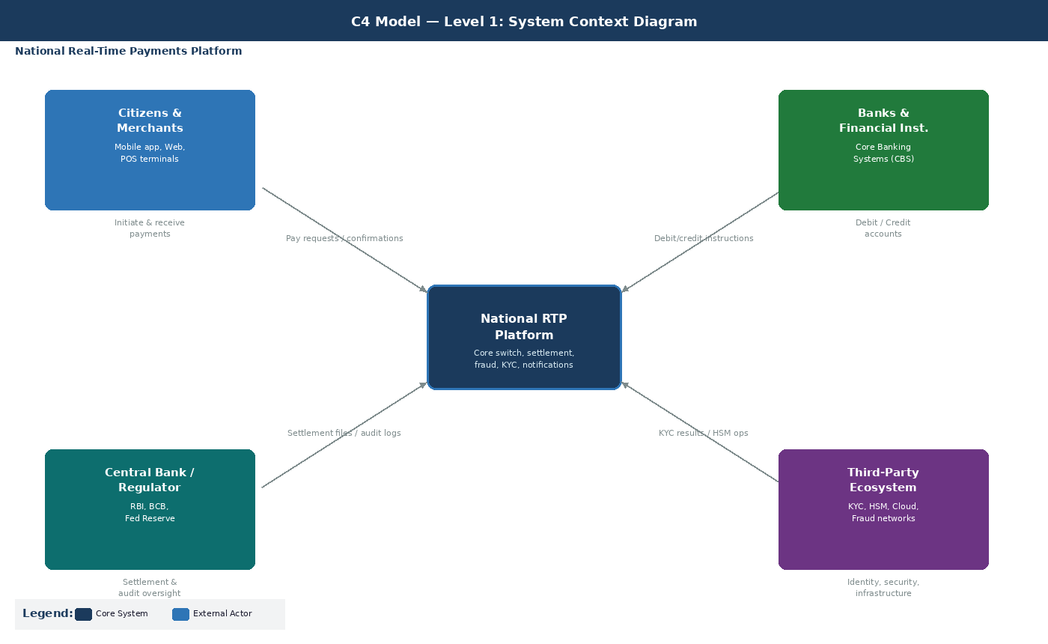
Figure 1: System Context: the RTP Platform and its four external actor groups

The Ten Major Systems
Moving one level inward, the platform decomposes into ten containers connected by an Apache Kafka event bus for asynchronous flows and direct synchronous calls where latency matters. Fraud scoring, for instance, has to return a result in under 100ms and cannot go through a queue.

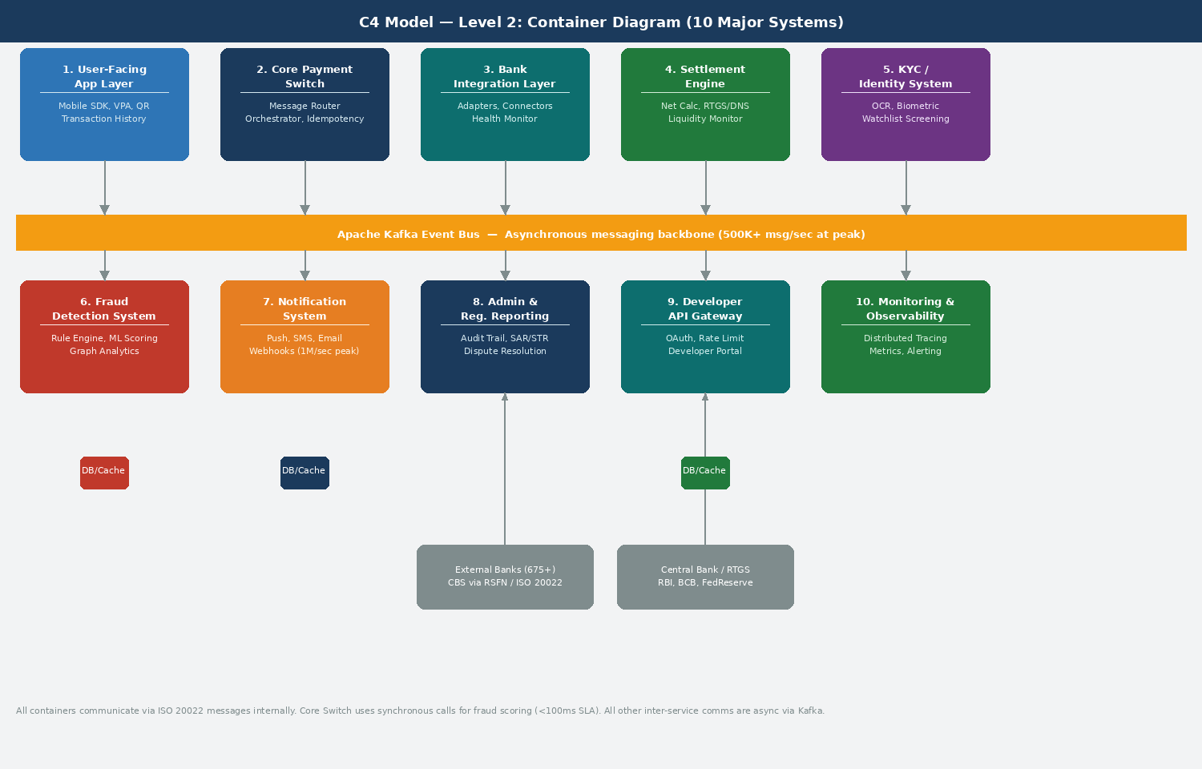
Figure 2: Container View: ten systems linked by the Kafka event backbone

Subsystem Detail

1. User-Facing Application Layer
Handles everything the end user touches. The design follows UPI's three-tier model: NPCI switch at the base, member banks in the middle, and PSP apps like PhonePe and Google Pay at the top.
Subsystem | Responsibility | Reference
Mobile SDK / Common Library | Device binding, PIN capture, and a standardised UX across all bank apps. UPI's Common Library enforces identical flows across 675 member banks so users get the same experience regardless of which bank they hold. | NPCI Common Library
VPA / Alias Service | Resolves identifiers (user@bank, phone number, email, tax ID) to real bank account numbers via the central directory. The user never types an account number. | UPI VPA, PIX DICT
QR Code Engine | Static QR codes for recurring merchants, dynamic COB codes for one-time amounts, and dynamic COBV codes for invoices that carry due dates and late fees. | PIX three QR types (BCB)
Transaction History | Retrieves past records. This component tolerates eventual consistency, so a few seconds of lag between a payment settling and appearing in history is acceptable. | All systems

2. Core Payment Switch
Routes all payment messages between institutions. Brazil's SPI and FedNow's clearing engine are direct equivalents in other systems.
Subsystem | Responsibility | Key Risk
Message Router | Validates message schema and routes requests between the payer's bank and the payee's bank. | Invalid or non-conforming message format
Transaction Orchestrator | Manages the state machine from start to finish: INITIATED, AUTHENTICATED, DEBITED, CREDITED, CONFIRMED. A transaction has to be in exactly one state at any point in time. | State corruption if the service crashes mid-flight
Idempotency Manager | Assigns UUID keys to every request. If a network failure causes a retry, the server detects the duplicate and returns the original result rather than processing the payment again. | Duplicate debits without this in place
Transaction Status Service | Returns payment status on query. Needs its own rate limits and physical isolation. The April 2025 UPI five-hour outage was caused by PSP banks flooding this service without waiting for responses. | API flood, a real, verified national-scale incident

3. Bank Integration Layer
Subsystem | Responsibility | Reference
Bank Adapter Framework | Protocol translators per bank. Some banks speak ISO 20022, some ISO 8583, and some use their own proprietary CBS APIs. UPI connects banks via an Enterprise Service Bus that sits between the switch and each bank's Core Banking System. | UPI ESB model
Connection Pool Manager | Maintains persistent, pre-warmed connections per bank using bulkhead isolation. One bank's slow API cannot exhaust the shared thread pool and reject requests to healthy banks alongside it. | Resilience4j Bulkhead
Message Transformation Engine | Converts the platform's canonical message format into each bank's native format on the way out, and back on the way in. | PIX uses the RSFN private network
Bank Health Monitor | Continuously probes bank API endpoints and feeds the results into the circuit breaker state machine for each integration. | Istio / Resilience4j

4. Settlement Engine
Subsystem | Responsibility | Model
Net Position Calculator | Computes multilateral net positions across all member banks. Used in deferred net settlement models like UPI and UK Faster Payments. | DNS (UPI, FPS)
Settlement File Generator | Produces settlement instructions for submission to the central bank's RTGS system at the end of each settlement cycle. | All systems
Liquidity Monitor | Ensures banks maintain adequate pre-funded positions in their central bank accounts. PIX banks must keep non-negative IP Account balances at BCB at all times. BCB provides standing liquidity facilities exceeding $6 billion per day to support this. | PIX IP Accounts (BCB)
Settlement Cycle Manager | Schedules and runs settlement cycles. Per-transaction for RTGS systems like PIX and FedNow. Batch cycles for DNS systems like UPI and UK FPS. | RTGS: PIX, FedNow. DNS: UPI, FPS

Systems 5 through 10
System | Key Subsystems | Scale Note
5. KYC / Identity | Document OCR, biometric verification, sanctions screening, risk scoring, AML monitoring. | India's Aadhaar eKYC enabled 491M users to onboard without visiting a branch.
6. Fraud Detection | Rule engine (under 1ms), ML scoring (under 50ms), graph analytics for fraud rings, device fingerprinting, behavioural biometrics, case management. | NPCI MuleHunter.AI, federated fraud model across all PSPs
7. Notification System | Push notification, SMS gateway, email, in-app messages, webhooks. | Two parties notified per payment means 1 million notifications per second at peak.
8. Admin and Regulatory | Immutable audit trail, SAR/STR report generator, compliance dashboard, dispute resolution. | PIX MED requires the receiving bank to block suspect funds within 30 minutes.
9. Developer API Gateway | API gateway, OAuth 2.0, rate limiting, developer portal, webhooks, API analytics. | PIX Open Finance handles 100 billion API calls per month.
10. Monitoring and Observability | Distributed tracing (OpenTelemetry and Jaeger), metrics (Prometheus and Grafana), log aggregation (OpenSearch), synthetic transactions. | Synthetic transactions catch outages before real users encounter them.
Question 2: Information Exchanged Between Systems
What data moves where, how fast, in what volume, and with what consistency guarantee. These are the questions that drive every integration and capacity decision. The two diagrams below look at the same flows from two angles.

Payment Sequence
The diagram traces a single payment through ten steps across six lanes. Every step has to complete within the 2-second end-to-end budget. The split is roughly: authentication and fraud screening in the first 200ms, bank debit and credit over the next 1.2 seconds, settlement and notification in the final 500ms.
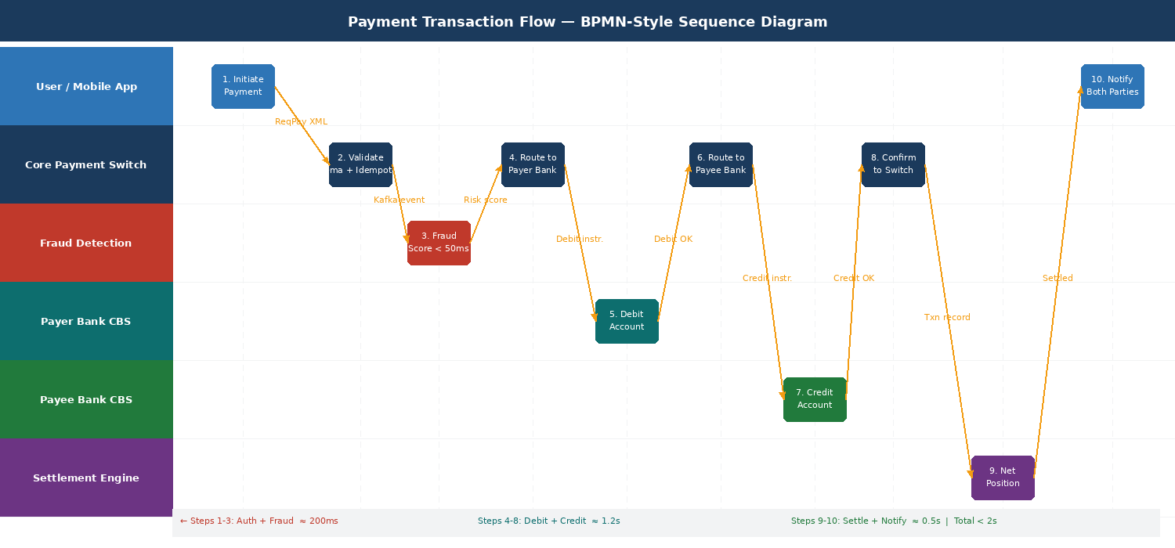
Figure 3: Payment sequence: 10 steps across 6 lanes with timing breakdown (auth 200ms, debit/credit 1.2s, settle and notify 500ms)

Data Flow Diagram
The DFD maps data movement between the six processing functions, three data stores, and four external entity groups. It makes visible which flows are per-transaction real-time and which are batch, and it shows which stores demand strong consistency versus which can tolerate eventual consistency.
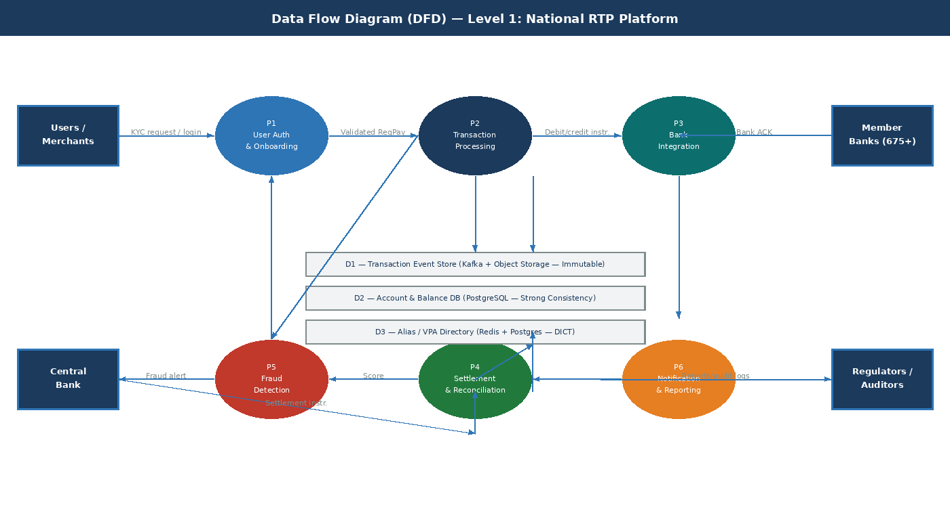
Figure 4: DFD Level 1: six processes, three data stores, four external entity flows

Data Exchange by System Pair
System Pair | Data Exchanged | Format | Synchronous? | Peak Volume | Consistency
User App to Core Switch | VPA, payee VPA, amount, device fingerprint, encrypted PIN, geolocation | UPI: proprietary XML. PIX and FedNow: ISO 20022 pacs.008 | Yes | 500K/sec | Strong
Core Switch to Fraud Detection | Transaction attributes, velocity counters, device data, behavioural history, geolocation | Apache Kafka JSON event | Yes, reply required in under 100ms | 500K/sec | Strong
Core Switch to Bank Integration | Debit and credit instructions, resolved account numbers, authentication tokens | ISO 20022 pacs.008 or bank's native CBS format | Yes | 500K/sec | Strong
Settlement Engine to Central Bank | Net positions (DNS) or per-transaction RTGS instructions | ISO 20022 pacs.009 | Batch or per-transaction | Aggregated | Strong
Core Switch to Notifications | Transaction ID, status, amount, party names, timestamp | Kafka event | No, fully async | 1M/sec | Eventual
Core Switch to Audit Trail | Every state transition with full context and timestamp | Kafka append-only topic to object storage | No, async | 500K/sec | Eventual
API Gateway to Partners | Payment initiation, status webhooks, account information (consent-gated) | REST JSON / OpenAPI 3.0 / ISO 20022 | Varies | Varies | Eventual

Frequency and Consistency Requirements
Flow Category | Frequency | Consistency | Rationale
Payment processing | Per-transaction, synchronous | Strong | A double debit or missed credit is a regulatory violation. There is no acceptable lag.
Fraud scoring | Per-transaction, synchronous | Strong | Stale fraud signals let known-bad accounts transact. Blacklists have to be current.
Settlement (RTGS) | Per-transaction, synchronous | Strong | Immediate finality in central bank money. Used by PIX, FedNow, EU TIPS, Australia NPP.
Settlement (DNS) | Batch, 3 to 24 times per day | Strong at batch time | Net positions must be exact. Intra-day credit risk is managed through prefunding requirements.
Notifications | Per-transaction, async | Eventual | Retry until delivered. A few seconds of lag is fine; the payment has already gone through.
Transaction history (reads) | Per user query | Eventual | Users tolerate 2 to 5 seconds of lag on their transaction list.
Analytics and reporting | Continuous stream, batch aggregation | Eventual | Minutes of lag are acceptable for operational dashboards and regulatory reports.
KYC onboarding | Per onboarding event | Strong | Identity verification has to be definitive before a new user is activated. Regulatory requirement.

Messaging Standards
ISO 20022 is now the global standard. SWIFT completed its full migration from MT103 to pacs.008 on 22 November 2025. UPI is the notable exception, still running on a proprietary XML protocol that NPCI built in 2016. That works fine domestically but makes cross-border expansion significantly harder compared to PIX and FedNow, which speak ISO 20022 natively.
System | Standard | Key Message Types
India UPI | Proprietary XML over HTTPS | ReqPay, RespPay, ReqAuthDetails: 16+ defined message types
Brazil PIX | ISO 20022 | pacs.008 (credit transfer), pacs.002 (status), pacs.004 (return), pain.013/014 (Request for Payment)
US FedNow | ISO 20022 | pacs.008, pain.013/014 (Request for Payment)
EU TIPS | ISO 20022 | pacs.008.001.08 with versioned schemas
Australia NPP | ISO 20022 | pacs.008 natively from launch in 2018
UK Faster Payments | ISO 8583 (migrating to ISO 20022) | Legacy standard; migration in progress

Question 3: Major Potential Failure Points
Nothing on this list is theoretical. Every failure mode below has either occurred in a live national payment system or represents a documented class of risk that operating systems actively work around. The sources are cited.

Risk Matrix
The matrix plots failures by likelihood and impact. Red zones require immediate architectural mitigation. Orange zones require defensive design. Green zones are monitored but do not drive architecture decisions.
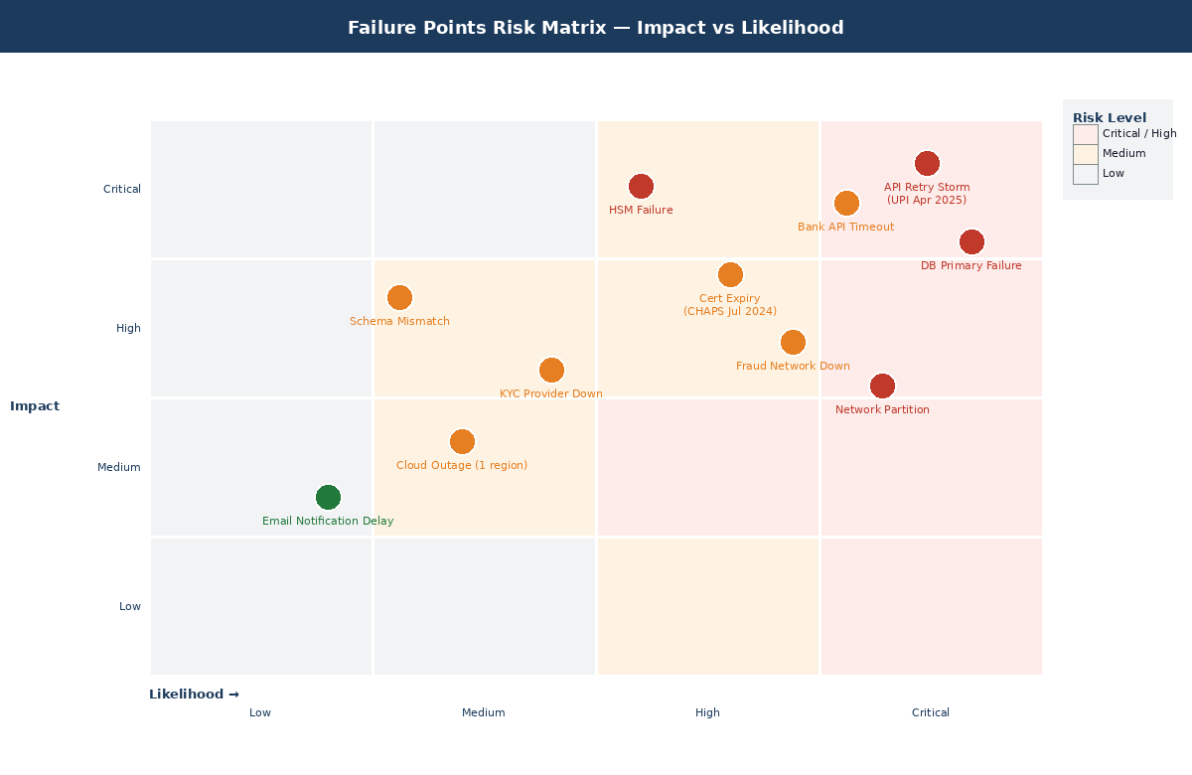
Figure 5: Risk matrix: Impact vs Likelihood. Every point is a real failure mode from a production system.

Technical Failures
Failure | Impact | Evidence
Database primary failure | All writes stop. At 500K TPS, five seconds of primary downtime means 2.5 million failed transactions. Synchronous replication lag between primary and replica can cause split-brain in active-active setups. | Mitigated in practice by NPCI's three-datacenter active-active-active topology across Chennai, Hyderabad, and a third site.
Network partition between data centres | Depending on where the partition falls, it isolates the switch from banks or from peer data centres, splitting the system's view of state. | PIX runs on RSFN, a private encrypted network completely separate from the public internet, specifically to eliminate this class of failure.
Connection pool exhaustion | A slow bank API holds connections open. The shared pool fills. Requests to healthy banks get rejected alongside the slow one. The damage spreads beyond the original cause. | This is what happened in April 2025 on UPI. One overloaded service exhausted shared infrastructure and brought down payment processing broadly. Bulkhead isolation is the direct fix.
HSM failure | All cryptographic operations stop: PIN verification, message signing, key management. Thales payShield HSMs secure roughly 80% of global point-of-sale transactions. | Must deploy in FIPS 140-2 Level 3 certified redundant pairs with automatic failover.
Expired TLS certificate | All encrypted connections to or from the affected service fail immediately with no warning to end users. | Bank of England CHAPS, 31 July 2024: 91 minutes of national payment downtime from a single expired certificate. Entirely preventable with automated renewal.

Integration Failures
Failure | Impact | Evidence
Bank API timeout | The most frequent integration failure mode. A slow Core Banking System holds threads open, backing up payment processing behind it. | UPI mandates bank API responses within 10 seconds (down from 30 seconds following the April 2025 incident). PIX auto-rejects requests with error AB03 after approximately 10 seconds.
API retry storm | When something fails, all upstream callers retry at once. The spike that results is larger than the original load that caused the problem. | Root cause of the April 2025 UPI outage. PSP banks sent Check Transaction Status calls without waiting for responses or respecting any retry interval. Success rates fell to around 50% for two hours, affecting roughly 40 million transactions per hour.
Malformed messages and version mismatch | Messages get rejected when a bank runs a system upgrade that produces non-conforming payloads, or when PSPs send requests outside the schema. | UPI error codes U16 (risk threshold exceeded) and U30 (debit completed but credit confirmation not received) show up in production logs during this failure class.
Schema drift | A bank updates its CBS API without coordinating with the central switch. Message parsing fails silently, and the failures show up as mysterious transaction errors rather than obvious integration problems. | ISO 20022 versioned schemas like pacs.008.001.08 help, but they require active governance to actually work.

External Dependency Failures
Failure | Impact | Evidence
KYC provider downtime | New user onboarding stops. Existing users and their transactions are unaffected. The critical design rule: new-user failures must never touch the live payment path. | Architectural principle, not a reactive fix.
Cloud provider regional outage | Banks that moved their Core Banking System to cloud lose the ability to process debits and credits until the region recovers. | Itau Unibanco moved PIX infrastructure to AWS. An AWS regional outage would take one of Brazil's largest PIX participants offline.
Fraud intelligence network unavailable | The system cannot pull fraud scores from the shared DICT infraction database. Fail open approves everything; fail closed blocks everything. Neither is workable. | PIX DICT data is shared across all participants. The right answer: pre-cached blacklists plus a local rule engine as a fallback, so the system degrades gracefully rather than failing completely.
Cyberattack on participant software | Fraud losses at scale even when the central infrastructure itself is untouched. | July 2025: an attack on software vendor C&M resulted in theft of more than R$540 million (approximately US$100 million) through PIX accounts. Sources: BCB, QED Investors.

Question 4: Mitigation Strategies
The mitigations below are grounded in production implementations. Each one is paired with the failure class it addresses and the system that validated it at scale.

Circuit Breaker
A circuit breaker wraps each bank integration and monitors the failure rate across a sliding window of recent calls. When the failure rate crosses a threshold, the circuit opens and all subsequent requests to that bank return a fallback result in microseconds rather than waiting for a timeout. After a cooling period, a small number of test requests probe whether the bank has recovered. If they succeed, the circuit resets. If they fail, it stays open.
Recommended Resilience4j configuration: failureRateThreshold at 50%, waitDurationInOpenState at 10 seconds, slidingWindowSize of 20 calls. Can be implemented in application code (Resilience4j in Spring Boot) or pushed down to the infrastructure layer via Istio service mesh policies.

Bulkhead
Without bulkheads, every bank integration draws from a common thread pool. When one bank is slow, its connections pile up in the pool until there is nothing left for anyone else. Banks that are working perfectly get rejected because a different bank's problem consumed their threads. That hidden coupling is what turned a single slow subsystem into a platform-wide outage on UPI in April 2025.
Sizing formula: (peak requests per second times average latency in seconds) plus 30% safety buffer. Each bank gets its own pool sized by this formula. When Bank A's pool saturates, Banks B through N keep running as normal.

Active-Active Multi-Datacentre Redundancy
NPCI runs in active-active-active mode across three geographically separated locations, including Chennai and Hyderabad. If one site goes dark the remaining two continue processing with no user-facing interruption. Running three active sites costs roughly 20% more than a primary-plus-disaster-recovery setup, but it eliminates recovery time entirely, which is what five nines actually requires.
Split-Brain Prevention
Deterministic routing: the data centre handling each transaction is determined by a hash of the transaction ID or account ID range.
This means exactly one data centre processes each payment, with no possibility of conflicting writes from two sites acting simultaneously.
Synchronous cross-DC replication adds roughly 5 to 20ms of round-trip latency per write, well within the 2-second budget.

Rate Limiting, Enforced at Infrastructure Level
The April 2025 UPI outage was entirely preventable. It happened because rate limits were not machine-enforced at the infrastructure layer. Banks and PSPs could call the Check Transaction Status API as fast as they liked, and they did. NPCI's post-incident guidelines (OC-215/2025-26) introduced hard limits that banks cannot override:
API Endpoint | Rate Limit | Enforcement Point
Check Transaction Status | Maximum 3 attempts per transaction with a minimum 90-second gap between each | API Gateway, hard limit
Balance Enquiry | 50 requests per user per day | API Gateway
List Accounts | 25 requests per user per day | API Gateway
AutoPay execution | Restricted to off-peak hours: before 10AM, 1 to 5PM, after 9:30PM | Scheduler with time-based rules
Background system-initiated calls | Blocked entirely during peak hours | Infrastructure firewall

Token bucket rate limiting at the API gateway handles burst tolerance. Pairing this with Kafka's consumer-pull model gives natural internal backpressure: consumers pull messages at their own sustainable pace rather than getting overwhelmed by a producer running too fast.

Additional Mitigation Patterns
Pattern | How It Works | What It Prevents
Fallback | Every service defines what happens when its dependency is unavailable. Fraud Detection falls back to a cached blacklist plus rule engine. Notifications fall back through Push, then SMS, then Email. | Partial failures becoming total failures
Idempotency Keys | Every API call carries a UUID v4. If a network failure triggers a retry, the server detects the duplicate and returns the original result without reprocessing. Stripe expires keys after 24 hours. | Duplicate debits from network-level retries
Dead Letter Queues | Messages that fail after 3 to 5 retries with exponential backoff go to a dedicated Kafka topic. Background workers pick them up and reattempt. Alerts fire when DLQ depth grows faster than it is being drained. | Silent message loss; main pipeline getting blocked
Strangler Fig Migration | Legacy bank CBS integrations get replaced incrementally. A new ISO 20022 adapter is deployed alongside the old one. Traffic is shifted gradually, 5%, then more, until the old adapter can be retired. | Downtime during migration of 675+ bank integrations
Blue-Green Deployment | Two identical production environments run in parallel. All traffic goes to Blue. New version is deployed to Green and tested with synthetic transactions. The router switches in seconds. Rollback means reverting the router. | Downtime on a system that cannot have maintenance windows
Certificate Lifecycle Management | Automated renewal through cert-manager or HashiCorp Vault PKI. Alerts fire at 30, 14, and 7 days before expiry. | The CHAPS July 2024 outage class, 91 minutes of national payment downtime from a single expired certificate
Chaos Engineering | Controlled failure injection before real failures happen: disable a bank node to test bulkheads, inject 5-second latency into the fraud service to test timeouts, terminate a data centre process to test failover. Tools: Gremlin, LitmusChaos. | Discovering resilience gaps only during real incidents

Question 5: Contingency Plans When Failures Occur
Good architecture reduces failure frequency. It does not eliminate it. The contingency plans below are based on how UPI, PIX, and UK Faster Payments actually handle recovery, not on theoretical runbooks.

Incident Response Tiers
Priority | Trigger | Response | Communication
P1: Critical | More than 10% transaction failure rate, or latency exceeding 30 seconds | Immediate SRE on-call page. Activate contingency runbook. Notify the central bank per the SLA. | In-app banner within 5 minutes. Status page updated. Social media acknowledged.
P2: High | 5 to 10% failure rate, or degraded latency | SRE investigates. Watch for P1 escalation. | In-app notification if users are affected directly.
P3: Medium | Under 5% failure rate, isolated to one bank or feature | Standard SRE queue. Root cause analysis within 24 hours. | No proactive communication unless users are visibly affected.

On Communication During Outages
Users should never find out about an outage from a failed transaction with no explanation.
During the April 2025 UPI outage, information spread across social media faster than any official channel. That significantly damaged user trust and took weeks to repair.
BCB publishes PIX availability metrics in real time on a public dashboard. That transparency is not an accident. It is a deliberate strategy for maintaining institutional credibility.

Contingency Plan 1: Manual Reconciliation
When automated debit-credit matching fails, three data sources get cross-referenced: the internal Kafka event log (append-only by design, so there is no data loss), bank settlement files downloaded from the central switch, and the switch's own definitive transaction state. Where these three disagree, a correction entry gets generated and pushed through the dispute resolution workflow. The two mismatch patterns that show up in practice are: a debit completed but credit not received (most common), and a credit posted but no corresponding debit found (rare).
Step | Action | Source of Truth
1 | Extract raw transaction event logs from Kafka. The append-only structure means the log is complete regardless of what else failed. | Kafka topic committed offsets
2 | Banks download settlement files from the central switch and reconcile against their Core Banking System records. | NPCI / BCB settlement file API
3 | Cross-reference all three sources. Flag every mismatch automatically. | Reconciliation engine
4 | Generate correction entries for each mismatch and route through dispute resolution. | Dispute Management System
5 | UPI mandates T+1 resolution for person-to-person reversals and T+5 working days for person-to-merchant refunds. RBI mandates Rs 100 per day in compensation for delays beyond these windows. | RBI guidelines

Contingency Plan 2: Deferred Settlement
When the real-time settlement infrastructure is unavailable, transactions move to a PENDING SETTLEMENT state and process on the next available settlement cycle. From the user's perspective, the payment succeeded, the only difference is that inter-bank wholesale settlement is deferred. No money is at risk.
System | Deferred Mechanism | Window
UPI (India) | Settlement moves to the next NPCI DNS cycle. A minimum of three cycles run every business day. Failed reversals queue for T+1 processing. | T+1 for P2P, T+5 for P2M
PIX (Brazil) | If BCB's STR system is down, banks can access the SPI Rediscount Facility, an emergency liquidity mechanism at a penalty rate. Banks pre-fund weekend and holiday liquidity to avoid needing it. Average PIX IP Account balance reached R$34.71 billion in H2 2024 because of this pre-funding requirement. | STR operational hours: 6:30AM to 6:30PM
UK Faster Payments | Falls back to DNS settlement in Bank of England reserve accounts. The prefunding model absorbs short-term infrastructure gaps. | Three settlement cycles per business day

Contingency Plan 3: PIX MED Fraud Recovery
Brazil's MED (Mecanismo Especial de Devolucao) is the most operationally mature fraud recovery mechanism running at national scale anywhere in the world. MED 2.0 became mandatory on 2 February 2026 and traces funds across up to five account layers, which directly counters the mule account chains that fraudsters use to obscure stolen money.
Step | Action | Deadline
1 | Victim reports fraud to their bank. | Immediately
2 | Victim's bank notifies the receiving bank. | Within 30 minutes of the victim's report
3 | Receiving bank blocks the funds. | Immediately on receiving notification
4 | Both banks analyse the case. | Within 7 days
5 | Funds returned to victim if fraud is confirmed. | Within 96 hours of confirmation
6 | Filing deadline for the fraud report. | 80 days from the transaction date
7: MED 2.0 | Automated DICT infraction notices trace funds across up to five account layers. | Mandatory from 2 February 2026

Contingency Plan 4: User Communication
Channel | Trigger | Message
In-app banner | Failure rate exceeds 5% | We are experiencing delays. Your money is safe. Please retry in X minutes.
Push notification | Transaction pending for more than 30 seconds | Your payment is being processed. Confirmation is on its way.
Public status page | Any P1 incident | Live component health with estimated resolution time. Modelled on BCB's public SPI availability dashboard.
SMS | Transaction in a failed state | Confirmation that any debit has been reversed.
Social media | Viral reports detected in monitoring | Official acknowledgement posted within 15 minutes.
Regulatory notification | Incident exceeds the central bank's mandated SLA | Mandatory filing per RBI, BCB, or FCA requirements depending on jurisdiction.

Question 6: System Behaviour, Normal Load vs Peak Events
The two demand profiles require completely different design decisions. Normal load is about steady-state efficiency. Peak load is about surviving a 10x spike without pre-provisioning for that spike permanently, which would be economically unworkable.

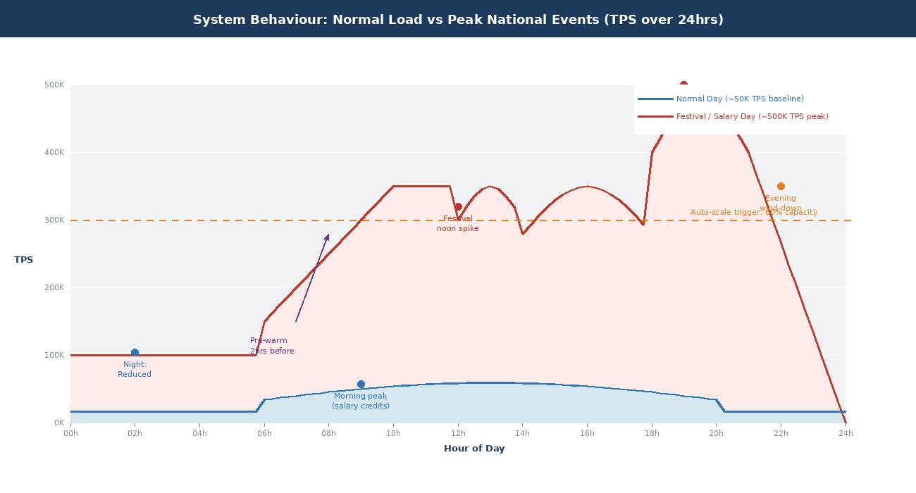
Figure 8: TPS across 24 hours: normal day (~50K baseline) vs festival or salary day (~500K peak). Pre-warm trigger and auto-scale threshold shown.

Normal Daily Load
System | Average Sustained TPS | Daily Transaction Volume | Reported Availability (2024)
India UPI | ~7,500 TPS | 640 to 700 million per day | ~99.99% (NPCI)
Brazil PIX | ~2,500 to 3,000 TPS | 180 to 220 million per day | 99.96% (BCB)
This System (Target) | 50,000 TPS baseline | ~4.3 billion at peak capacity | 99.999% (target)

Under normal load the system runs in steady-state auto-scaling mode. The scale-out trigger fires at 60 to 70% of baseline capacity, which gives new instances time to warm up before the threshold is actually hit. All releases use canary deployment: 1% of traffic goes to the new version for 30 minutes, then the system either promotes automatically or rolls back. NPCI has not had a scheduled maintenance window since 2016.

UPI Lite: The Most Consequential Load Optimisation
UPI Lite runs transactions from an on-device pre-funded wallet. No internet required, no PIN required, no bank CBS involved.
Roughly 50% of all UPI transactions are under Rs 200. Every one of those can run through Lite instead of the core infrastructure.
That offloads half the transaction volume from bank Core Banking Systems. The equivalent capacity gain would cost far more to achieve through raw infrastructure spend.
UPI Lite X takes this further with NFC-based fully offline payments between two devices with no connectivity on either side.
For a platform targeting rural populations, where connectivity is unreliable, offline payment is not a convenience feature, it is what financial inclusion actually means in practice.

Peak National Events: Verified Data
Event | System | Verified Record | Availability
13th salary day and year-end spending | PIX (Brazil) | 252.13 million transactions in a single day (R$162.9 billion). 20 December 2024. | 99.96% maintained
Year-end plus salary (new record) | PIX (Brazil) | 276.7 million transactions in a single day (R$135.6 billion). 6 June 2025. | 99.96% maintained
December 2025 monthly record | UPI (India) | 21.63 billion transactions in a single calendar month. | ~99.99% maintained
Full year 2025 | UPI (India) | 228.3 billion transactions, representing 49% of global real-time payment volume. | Maintained throughout

Both PIX single-day records fell on Fridays. Fridays are consistently the highest-volume day because of weekly salary cycles. That predictability matters operationally: the system can pre-warm before a known high-load date rather than scrambling to react after load arrives.

Handling the 500,000 TPS Spike
Strategy | How It Works | Validated By
Calendar-driven pre-warming | Spin up additional compute hours before predicted events. Diwali, month-end salary days, tax deadlines, and public holidays are all predictable. Kubernetes HPA combined with KEDA (Kafka Event-Driven Autoscaling) enables sub-minute scale-out triggered by rising Kafka consumer lag. | NPCI festival capacity planning
Traffic shaping | Token bucket rate limiting smooths burst arrivals and prevents the thundering herd problem, where all users retry simultaneously after a brief interruption and create a traffic spike larger than the one that caused the problem. | Post-UPI-outage enforcement, April 2025
Priority queuing | Four tiers: payment processing at the top, then transaction status, then balance enquiry, then analytics. Lower tiers get shed under capacity pressure with HTTP 429 responses and Retry-After headers. The degradation is graceful and explicit. | Kafka partition priority queuing
AutoPay time restrictions | AutoPay mandates and background system-initiated API calls are blocked during defined peak hours. NPCI introduced this as part of OC-215/2025-26 following the April 2025 outage. | NPCI OC-215/2025-26
Liquidity pre-positioning | Banks pre-fund settlement accounts before weekends and national holidays. BCB enforces this for PIX. Average PIX IP Account balances reached R$34.71 billion in H2 2024 directly because of this requirement. | BCB PIX H2 2024 management report
Pre-event chaos testing | Controlled failure injection runs 72 hours before predicted peaks. Validates that circuit breakers, bulkheads, and failover paths are all operational before real demand arrives. | Google DiRT / Netflix ChAP methodology

Question 7: Architectural Trade-offs
Four trade-offs dominate the design of this system. All four have been resolved one way or another by the production systems in the reference set. The decisions below are grounded in what those systems found in practice.

Trade-off 1: Consistency vs Availability
The CAP theorem says that during a network partition a distributed system has to choose between consistency (every node returns the same data) and availability (every request gets a response). Payment systems cannot make this choice globally. The right approach is to make it component by component based on what each component's data actually means.

CAP theorem applied: CP for the transaction hot path, AP for notifications and analytics.
Component | Choice | Rationale
Account balances | CP | A stale read enabling a duplicate debit is a regulatory violation. No exceptions.
Transaction state machine | CP | A transaction must be in exactly one state at all times. Exactly-once processing is a hard requirement.
Settlement positions | CP | Financial finality cannot be approximate. PIX RTGS settles each transaction individually in central bank money.
Fraud blacklists | CP | A stale blacklist lets known-fraudulent accounts transact. The data must be current.
Notification delivery | AP | Retry until delivered. Seconds of lag after a payment succeeds is tolerable.
Transaction history (reads) | AP | Users accept a 2 to 5 second lag on their transaction list. Availability of the read path matters more here.
Analytics dashboards | AP | Minutes of lag are fine for operational views. These are not financial records.
KYC onboarding | CP | Identity verification must be definitive before a new user is activated. Regulatory requirement.

PACELC: The Latency Dimension
Even without network partitions, there is a latency-consistency trade-off on every write.
Synchronous multi-datacenter replication adds roughly 5 to 20ms per write.
The right call is to accept that latency. Financial correctness is worth more than shaving milliseconds off the write path.
PIX demonstrates this clearly: during a BCB infrastructure outage, PIX stops accepting new transactions rather than risk consistency. That is the correct choice.

Trade-off 2: Cost vs Reliability
Availability | Annual Downtime | Architecture | Relative Cost
99% | 87.6 hours | Single region, no disaster recovery | 1x
99.9% | 8.76 hours | Single region with warm DR standby | ~3x
99.99% | 52 minutes | Multi-region active-passive | ~10x
99.999% | 5 minutes 15 seconds | Multi-region active-active, required for this system | ~50x

91% of enterprises put downtime costs at $300,000 to $1,000,000 per hour (Splunk). At UPI's scale that number is larger. The five-hour April 2025 outage, at 40 million transactions per hour, makes the arithmetic straightforward: the cost of five-nines infrastructure is small relative to the cost of not having it.
How to Reduce Cost Without Reducing Reliability
Apply active-active only to the transaction hot path: Core Switch, Bank Integration, and Settlement Engine.
Use active-passive (warm standby) for less critical systems: KYC, Admin Reporting, Developer Portal.
Use spot or preemptible compute for analytics and batch workloads where a restart is acceptable.
This targeted approach cuts total infrastructure cost by roughly 30 to 40% versus applying active-active everywhere.

Trade-off 3: Real-Time vs Eventual Processing
Requirement | Components | Why
Must be real-time with strong consistency | Debit and credit operations (must be atomic), balance check before debit (prevents overdraft), fraud scoring (before authorisation, target under 100ms), RTGS settlement (PIX, FedNow, TIPS, NPP). | Errors in these flows have direct financial and legal consequences. There is no acceptable lag, even small.
Can be eventual with relaxed consistency | Notification delivery, analytics dashboards, regulatory reporting (daily and monthly aggregation), user-facing transaction history, overnight reconciliation. | Significant performance and scalability gains. Users tolerate small delays in flows that do not involve the movement of money.

UPI's deferred net settlement is the clearest illustration of how this works in practice. Individual payments are real-time and consistent from the user's perspective. But inter-bank wholesale settlement runs in batches, with net positions cleared multiple times daily. User-facing consistency and wholesale settlement efficiency are two separate design problems, and treating them separately is what lets UPI handle 228 billion transactions a year.

Trade-off 4: Security Depth vs User Experience
System | Authentication Model | Adoption Outcome
India UPI | Device binding (Factor 1) plus a 4 or 6 digit PIN (Factor 2). No bank redirect for standard transactions. No OTP per payment. UPI Lite removes even the PIN for amounts under Rs 1,000. | 491 million registered users. 85% market share of India's digital payment volume.
Brazil PIX | Authentication through the user's own bank app using biometric, PIN, or password. One redirect per transaction. | 96% of Brazilian adults using PIX by 2024. 20% were using electronic payments for the first time.
US FedNow | Authentication delegated entirely to participating banks. No mandated UX standard. | Significantly slower adoption than UPI or PIX. Absence of a standardised experience is a contributing factor.

Users are twice as likely to complete a payment within a single interface rather than being redirected to another app. Reducing checkout friction by one step cuts abandonment by up to 35%. Security and experience are not opposites, they are a calibration problem.
Recommended: Adaptive Step-Up Authentication
Under Rs 1,000: Device possession only. No PIN. No app switch. (UPI Lite model)
Rs 1,000 to Rs 25,000: Device plus PIN. Two clicks. (Standard UPI model)
Above Rs 25,000: Device plus PIN plus biometric confirmation.
Anomalous behaviour flagged by fraud engine: step up to OTP and biometric regardless of amount.
First transaction to a new payee: additional confirmation prompt.
Result: UPI-grade experience for the 80% of routine low-value transactions, with proportionate friction for high-risk ones.

Question 8: Global Benchmarks, Recommended Features, and Economic ROI
Comparing the world's leading systems side by side reveals where the genuine differentiators are, which features drive adoption beyond infrastructure basics, and what the quantified return on this investment actually looks like.

Global System Comparison
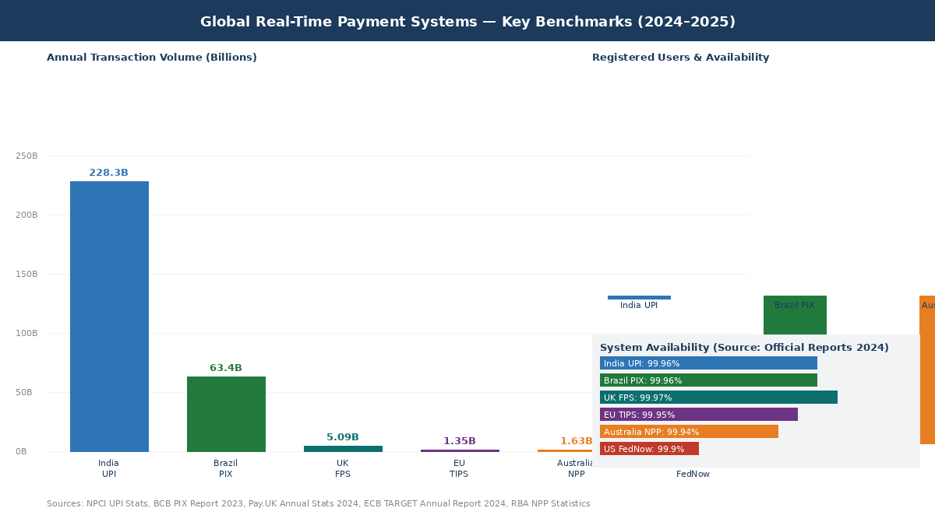
Figure 10: Global RTP benchmarks: annual volume, user adoption, and system availability (2024 to 2025, verified data)
Feature | India UPI | Brazil PIX | UK FPS | US FedNow | Australia NPP
Settlement model | DNS, deferred net | RTGS, central bank money | DNS, prefunded | RTGS, Fed reserves | RTGS, RBA
Addressing system | VPA alias (user@bank) | DICT: 5 key types (tax ID, company ID, email, phone, random) | Sort code plus account | Routing plus account number | PayID (phone, email, ABN)
Latency | Under 30 seconds | 3 to 5 seconds | Around 15 seconds | Seconds | Under 15 seconds
Offline payments | Yes, UPI Lite and UPI Lite X NFC | No | No | No | No
Cross-border | Live in 15+ countries | In development | No | No | Limited
Request for Payment | Limited | Pix Cobranca with full invoicing | No | Yes, ISO 20022 | Yes
Annual volume | 228.3 billion (2025) | 63.4 billion (2024) | 5.09 billion (2024) | Rapidly growing | 1.63 billion (2024)
User adoption | 491 million users | 96% of Brazilian adults | N/A | Limited | 25 million PayIDs

Recommended Features and Their ROI
Feature | Production Evidence | Quantified Impact
Conversational payments (voice and WhatsApp) | NPCI launched Hello! UPI for voice payments in Hindi and English, developed with IIT Madras AI4Bharat. WhatsApp Pay processed around 67 million UPI transactions per month in June 2025 after NPCI removed user caps, now available to all 596.6 million Indian WhatsApp users. | Reduces cart abandonment by up to 35%. Doubles payment completion rates in conversational interfaces. For 150 million users, 5% additional transaction completion = millions of incremental daily transactions at near-zero marginal infrastructure cost.
Offline payments (UPI Lite model) | UPI Lite achieves a 99.9% success rate even during peak hours because transactions bypass bank CBS entirely. About 50% of UPI transactions are under Rs 200. UPI Lite X enables fully offline NFC payments with no internet on either device. | Offloads 50% of transaction volume from bank CBS. The equivalent capacity gain from raw infrastructure would cost far more. Enables payments in areas with unreliable connectivity.
CBDC integration readiness | India's Digital Rupee achieved UPI-CBDC interoperability: users pay at existing UPI QR codes from CBDC wallets with no new merchant onboarding. Brazil's Drex CBDC entered its second pilot phase in 2025. 91% of central banks are exploring digital currencies (BIS survey). | Near-zero cost to build the adapter layer now. Retrofit cost after a CBDC launches: tens of millions. Building now is pure optionality at negligible cost.
Open Banking API ecosystem | Brazil's Open Finance processes 100 billion monthly API calls with 60 million active consents, four times the UK Open Banking volume. India's Account Aggregator framework enables consent-gated data sharing, unlocking credit for thin-file borrowers. | Global open banking value: $57 billion in 2023, growing at 26% annually. Positions the platform as infrastructure for a whole fintech ecosystem. Third-party innovation at zero cost to the platform operator.
AI spend analytics | Revolut and Monzo use ML-based transaction categorisation, spending prediction, and personalised insights. The transaction data already flows through the platform, so this is zero marginal data cost. | 20 to 50% reduction in budgeting errors. 5+ hours saved per month per user. The same data enables alternative credit scoring for thin-file borrowers.
Request for Payment | FedNow's RfP (ISO 20022 pain.013/014) lets businesses present payment requests directly in a customer's banking interface. The customer approves in one step with pre-filled details. | UK Open Banking RfP: 40% year-on-year growth. Eliminates invoice chasing. Reduces late payments for businesses substantially.

Economic ROI: Verified Data
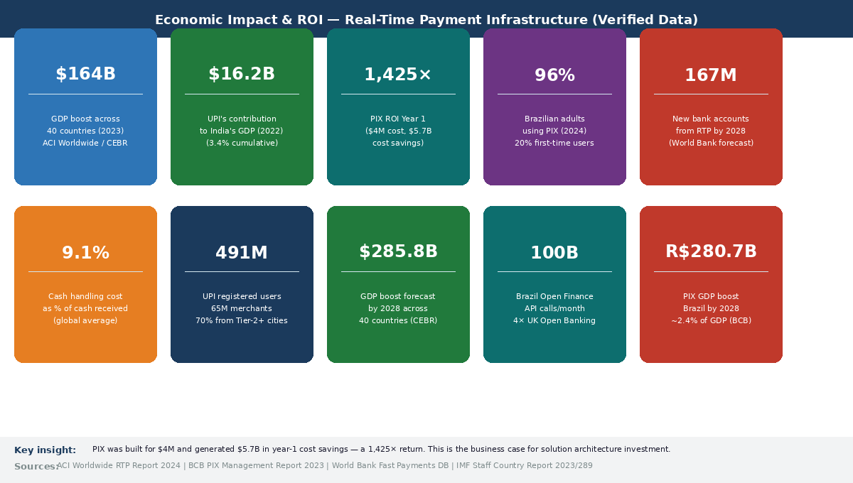
Figure 12: Economic impact: all figures from verified sources (ACI Worldwide, BCB, World Bank, IMF, 2023 to 2025)
Impact Category | Verified Metric | Source
GDP boost across 40 countries in 2023 | $164 billion increase attributable to real-time payment systems | ACI Worldwide / CEBR (2024)
GDP boost, global forecast 2028 | $285.8 billion projected | ACI Worldwide / CEBR (2024)
UPI contribution to India's GDP | $16.2 billion in 2022. Equivalent to 3.4% of cumulative annual GDP from 2016 to 2024. | Kearney analysis / IMF Staff Country Report
PIX contribution to Brazil's GDP | R$280.7 billion by 2028, approximately 2.4% of Brazil's GDP | BCB PIX Management Report 2023
PIX Year 1 ROI | Built for $4 million. Generated $5.7 billion in cost savings in its first year of operation. That is a 1,425x return. | BCB official data
Brazilian financial inclusion | 96% of Brazilian adults using PIX by 2024. 20% had never used electronic payments before. | BCB PIX Report 2023
India financial inclusion | 491 million individual users and 65 million merchants on UPI. 70% of users are from Tier-2 cities and below. | NPCI Statistics 2025
New bank accounts from RTP globally | 167 million new bank account holders projected from real-time payment adoption by 2028 | World Bank Fast Payments Database
Cash handling cost | Cash costs businesses 9.1% of cash received on average. Processing $100K in cash requires 542 labour hours versus 189 hours digitally. | BCG / World Bank research

Verified Sources

Official Central Bank and Regulator Sources
- NPCI, UPI Product Overview and Statistics: https://www.npci.org.in/what-we-do/upi
- NPCI International, UPI Global Expansion: https://www.npciinternational.in/upi/
- Reserve Bank of India, Data Localisation Circular (April 2018): https://rbidocs.rbi.org.in/rdocs/notification/PDFs/NOTI294A697D8F4D54E1AB19B4FB1B00F4D8.PDF
- Banco Central do Brasil, PIX Management Report 2023: https://www.bcb.gov.br/content/estabilidadefinanceira/pix/relatorio_de_gestao_pix/pix_management_report_2023.pdf
- Banco Central do Brasil, PIX Official Overview: https://www.bcb.gov.br/en/financialstability/pix_en
- European Central Bank, TIPS Overview: https://www.ecb.europa.eu/paym/target/tips/html/index.en.html
- European Central Bank, TARGET Services Annual Report 2024: https://www.ecb.europa.eu/press/targetservar/html/ecb.targetservar2024.en.html

Technical and Industry Sources
- AWS Architecture Blog, Modernization of Real-Time Payment Orchestration: https://aws.amazon.com/blogs/architecture
- Microservices.io, Circuit Breaker Pattern: https://microservices.io/patterns/reliability/circuit-breaker.html
- Microservices.io, Saga Pattern: https://microservices.io/patterns/data/saga.html
- Juspay, FedNow vs PIX vs UPI User Experience Comparison: https://hyperswitch.io/blog/a2a-payment-experience-fednow-vs-pix-vs-upi
- Certcube, NPCI Mobile Application Security Framework for UPI 2025: https://blog.certcube.com/npcis-comprehensive-mobile-application-security-framework-for-upi-2025/
- Medianama, NPCI AI Risk Scoring for UPI Fraud Detection: https://www.medianama.com/2025/04/223-npci-ai-upi-fraud-detection/
- Payments Dive, Real-Time Lessons for FedNow from Brazil and India: https://www.paymentsdive.com/news/federal-reserve-real-time-payments-fednow-brazil-india/716767/
- QED Investors, Brazil as a Global Testbed for Financial Crime Prevention: https://www.qedinvestors.com/blog/frontlines-of-fraud
- Elets BFSI, UPI December 2025 Record Transactions: https://bfsi.eletsonline.com/upi-smashes-records-with-21-6-billion-transactions-in-december-2025/
- Stripe, Guide to PIX Payments in Brazil: https://stripe.com/en-br/resources/more/pix-replacing-cards-cash-brazil
- Wikipedia, Unified Payments Interface: https://en.wikipedia.org/wiki/Unified_Payments_Interface
- Wikipedia, PIX Payment System: https://en.wikipedia.org/wiki/Pix_(payment_system)
- Wikipedia, ISO 20022: https://en.wikipedia.org/wiki/ISO_20022

